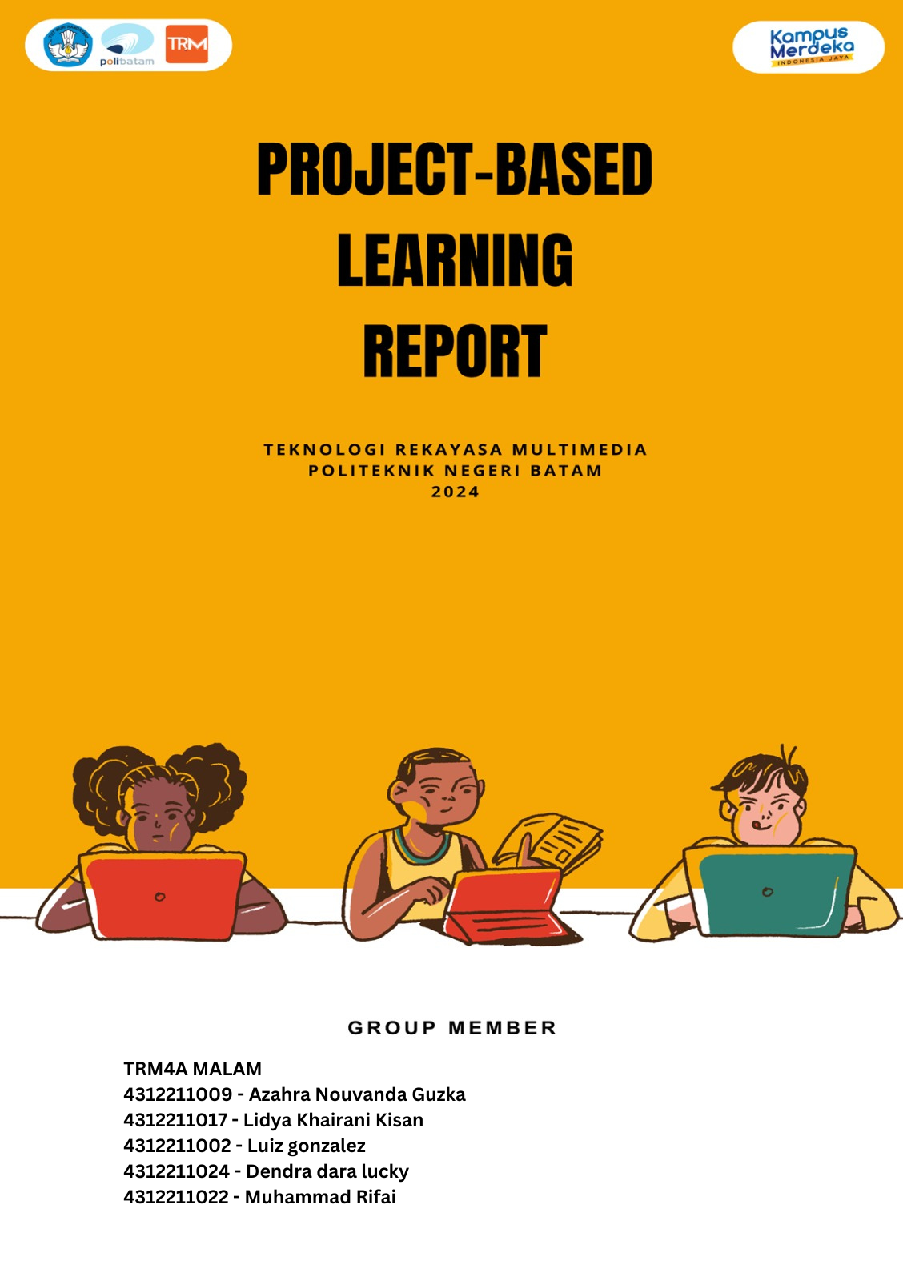

**June, 2024**

MULTIMEDIA ENGINEERING TECHNOLOGY BATAM STATE POLYTECHNIC

Compiled by: Evening 4A Group TRM-4A02

# PROJECT IDENTITY

Project Title : Scale Mobile Application

Project Owner : Sandi Prasetyaningsih,S.T., M.Media

Project Manager : Agung Riyadi, S.Si. M.Kom

Project Co-Manager : -

Client : Agung Riyadi, S.Si. M.Kom

|  |  |
| --- | --- |
| ✓ | Final Report |
| ✓ | Product: *Mobile Application*/~~Hardware/video~~* |
| ✓ | Demo video /~~trailer~~* |
| ✓ | Scientific Poster |
| ✓ | Intellectual Property Rights Document |
| ✓ | Handover Document |
|  | Contest Proposal (optional) |

Outputs :

**Group PBL TRM-4A02:**

1. Azahra Nouvanda Guzka - 4312211009

2. Lidya Khairani Kisan - 4312211017

3. Muhammad Rifai - 4312211022

4. Luiz Gonzalez - 4312211024

5. Dendra Dara Lucky - 4312211002

Approved by,

Batam, 26 June 2024

Agung Riyadi, S.Si. M.Kom

NIK. 119221

# LIST OF CONTENT

PROJECT IDENTITY iii

LIST OF CONTENT iv

LIST OF FIGURES v

LIST OF TABLES vi

1. PROJECT-BASED LEARNING PRODUCT xii

1.1 Product Description xii

1.2 Product Design xii

2. PRODUCT IMPLEMENTATION xviii

2.1 Product Implementation xviii

3. CONCLUSION 1

3.1 Obstacle 1

3.2 Learning Process 1

APPENDIX I – LOGBOOK 2

APPENDIX II – TEAM SCHEDULE 3

APPENDIX III – PROJECT BOARD 3

APPENDIX IV – PRESENTATION SLIDES 4

APPENDIX V 11

# LIST OF FIGURES

**Picture 1 Use Case xiv**

**Picture 2 Er Diagram xv**

**Picture 3 Interface Design xviii**

**Picture 4 Scheme Design xviii**

**Picture 5 Logo xix**

**Picture 6 Previous Logo xix**

**Picture 7 Welcome Page xix**

**Picture 8 Dashboard xx**

**Picture 9 Start Scale xxi**

**Picture 10 Automatic Scale Page xxi**

**Picture 11 Welcome Page xxii**

**Picture 12 Dashboard xxiii**

**Picture 13 Automatic Scale xxiv**

**Picture 14 Logbook History 2**

**Picture 15 Ppt presentation 4**

# LIST OF TABLES

**Table 1 Document History vii**

**Table 2 Project Work History ix**

**Table 3 Function Requirement xiii**

**Table 4 Non-Function Requirement xiv**

**DOCUMENT HISTORY**

Table 1 Document History

|  |  |  |
| --- | --- | --- |
| **Date** | **Writer** | **Description** |
| 18 / 1 / 24 | All members | Pbl group creation |
| 29 / 1 / 24 | All members | Creation of a pbl group with the project manager |
| 12 / 2 / 24 | All members | Understand and analyze project requirements (RPP) |
| 15 / 2 / 24 | All members | Conduct and search for reviews of the progress of the application you want to make on the internet |
| 17 / 2 / 24 | All members | Met with mapro and discussed the creation of an IoT system-based application |
| 20 / 2 / 24 | All members | Collect data, what materials and equipment you want to use in this PBL |
| 29 / 2 / 24 | All members | Experiment with the tool with project manager tools needed for this scale mobile application |
| 1 / 3 / 24 | All members | Select the title of the application you want to create |
| 2 / 3 / 24 | Azahra | Making UI designs for mobile scale applications |
| 3 / 3 / 24 | Lidya | Carry out UX application design |
| 4 / 3 / 24 | Azahra, Rifai | Purchase of tools |
| 7 / 3 / 24 | Dendra | Creation of application logo |
| 13 / 3 / 24 | Rifai | IoT device connector |
| 15 / 3 / 24 | Luiz | Running a test of the Arduino Lolin weighing sensor, IoT Device Programming |
| 17 / 3 / 24 | Dendra | Creating application use cases |
| 18 / 3 / 24 | Azahra | Creating entity relationship diagram applications |
| 21 / 3 / 24 | Lidya | Making PBL progress reports |
| 20 / 3 / 24 | Luiz | Running the scale sensor |
| 21 / 3 / 24 | Lidya | Manufacture of weighing boards |
| 29 / 4 / 24 | Dendra, Azahra, Lidya | Making an Indonesian insight poster |
| 8 / 5 / 24 | Azahra | Demonstration of application UI projects using Visual Studio Code and Android Studio |
| 13 / 6 / 24 | All members | Meeting with the examining lecturer, discussing connecting fluter to an IoT device |
| 21 / 6 / 24 | Dendra | Pbl poster making |
| 22 / 6 / 24 | Rifai, Azahra | Making pbl powerpoint |
| Lidya | preparation of PBL reports |

**PROJECT WORK HISTORY**

Table 2 Project Work History

|  |  |  |
| --- | --- | --- |
| **Stages** | **Completion Date** | **The resulting output** |
| Planning | 15 – 22 February 2024 | Conduct the first meeting with the manpro, plan the budget, products, tools, and fill out the RPP |
| Planning | 22 – 23 February 2024 | Hold meetings between groups. Discuss and make a comprehensive list of tools to be purchased and used |
| Design | 26 – 28 February 2024 | Designing user interfaces, logos, colors and application names for mobile scales based on nationality |
| Analysis | 29 February – 2 March 2024 | meeting with manpro. discuss and practice directly, the tools that will be used later. for mobile scale we use Arduino-MCU Lolin V3 |
| Design | 4 – 8 March 2024 | Create and design UI Design. welcome page, star page, dashboard, automatic scale page. Adapt the design to the application you want to use. carry out UX design |
| Implementation | 11 – 16 March 2024 | Assembling IoT devices, ensuring sensors are connected and lollin works, carrying out the process of implementing UI into Flutter |
| Implementation | 18 – 21 March 2024 | Make improvements to the sensor section, by making a sensor base (tray/container) at the top. Where the container will be made using cardboard which can support the weight of an object +- 10 kg |
| Implementation | 15 – 26 April 2024 | Carrying out the process of creating application UI using Android Studio and Visual Studio Code. displays the UI on the emulator |
| Implementation | 01 – 17 May 2024 | The final result is a Flutter prototype, maximizing functions, features and also making adjustments to the IoT Flutter device in Visual Studio Code |
| Implementation | 20 – 27 May 2024 | Ensure that IoT devices in the form of sensors and lollin node mcu are connected to the Arduino IDE, so that they can display results |
| Implementation | 28 May – 05 June 2024 | Trying to connect flutter to IoT device. Try weighing light items up to under 10 kilograms using a sensor connected to the ARDUINO IDE application |
| Implementation | 10 – 13 June 2024 | Hold a meeting with a mobile device programming lecturer. Namely discussing solutions on how to connect Flutter to IoT devices directly |
| Implementation | 14 – 22 June 2024 | Made a series of iterative improvements in connecting flutter to IoT devices. Try various trial error approaches until you succeed in connecting it. We also test integration on smartphones to ensure optimal compatibility |
| Implementation | 24 – 26 June 2024 | Combining application files, creates a way to install applications without going through Google Play so that they are easy to access and download |

# PROJECT-BASED LEARNING PRODUCT

## Product Description

The mobile scale application is an application designed to help users measure various types of kitchen spices precisely and accurately using their smartphone. This application allows users to measure the weight of kitchen spices such as salt, sugar, spices, flour, and so on. These apps usually have user interfaces that are intuitive and easy to use, with clear buttons and controls so users can easily access the features they need.

Mobile scale is a simple application targeted at housewives. By removing the login step, users can immediately use the application without having to remember or enter login information every time they want to use it. As an application aimed at housewives, simplicity and ease of use are priorities. Removing the login feature will strengthen the impression that the application is user-friendly and easy to use for those who may not be very familiar with technology.

With a combination of user-friendly UI design and the right use of colors and patterns, it is hoped that the "Great Scale" application will provide a pleasant and effective experience for users without the need to involve a login or database.

## Product Design

Product design for a mobile application project should have the following design:

* 1. **General system description.**

The mobile scale application is software designed as a portable weight measuring tool. Various types of mobile scale applications exist, including those used to measure the weight of small objects such as kitchen spices that weigh under 10 kilograms.

In this general design, the sustainability and maintenance of the system is also taken into account. Application development and firmware updates on IoT Systems must be well organized to ensure the availability of the latest features and performance improvements. Additionally, integration with cloud services enables efficient data storage and analysis. The overall design aims to create a solution that is easy to use, secure and responsive, providing users with an up-to-date and connected weight measurement experience.

* 1. **Functional system requirements.**

Functional system requirements for mobile scale applications can include various aspects that ensure the application can operate well and meet user needs.

* The application is able to provide accurate weight measurements for spice types, with minimal margin of error.
* The user UI/UX should be well designed and easy for the user to understand.
* The application must respond quickly to user commands and provide real-time weight readings.
* The application must be compatible with various types of smartphones and commonly used operating systems such as Android.
* Applications must be accompanied by clear documentation and adequate user guidance.
* **Functional Requirement**

Functional requirements are the basic requirements needed by the system to receive and process actions from its users. The following are the functional requirements of a mobile scale application system.

Table 3 Function Requirement

|  |  |
| --- | --- |
| FR-01 | The application does not require a login feature for user efficiency |
| FR-02 | The application displays a list of functions according to the access rights of each user |
| FR-03 | Users should be able to select the unit of measurement (e.g., grams, kilograms, ounces, pounds) according to their preference or requirement. |
| FR-04 | The application displays something about the scales |
| FR-05 | Users should have the ability to adjust the zero point of the scale for precise measurements. |
| FR-06 | The application should be available on major mobile platforms such as iOS and Android to cater to a broader user base. |
| FR-07 | The application is able to provide information on each material that is being weighed |

* **Non-Functional Requirement**

Non-Functional Requirements specify quantitative measures that must be met by mobile scale applications. Following are several Non-Functional requirements based on the criteria and parameters.

Table 4 Non-Function Requirement

|  |  |
| --- | --- |
| **Criteria** | **Parameter** |
| Avaibility | The system is capable of running 24 hours non-stop, unless there is system maintenance or system updates. |
| Ergonomy | The system can be accessed easily or is user friendly. |
| Language | Using Indonesian (optional English) |
| Safety | The browser must accept the SSL certificate from the system. |
| Product | Website and desktop based applications. |
| Visual | Designed with a simple appearance that can attract the attention of website users. |

* 1. **Use case.**

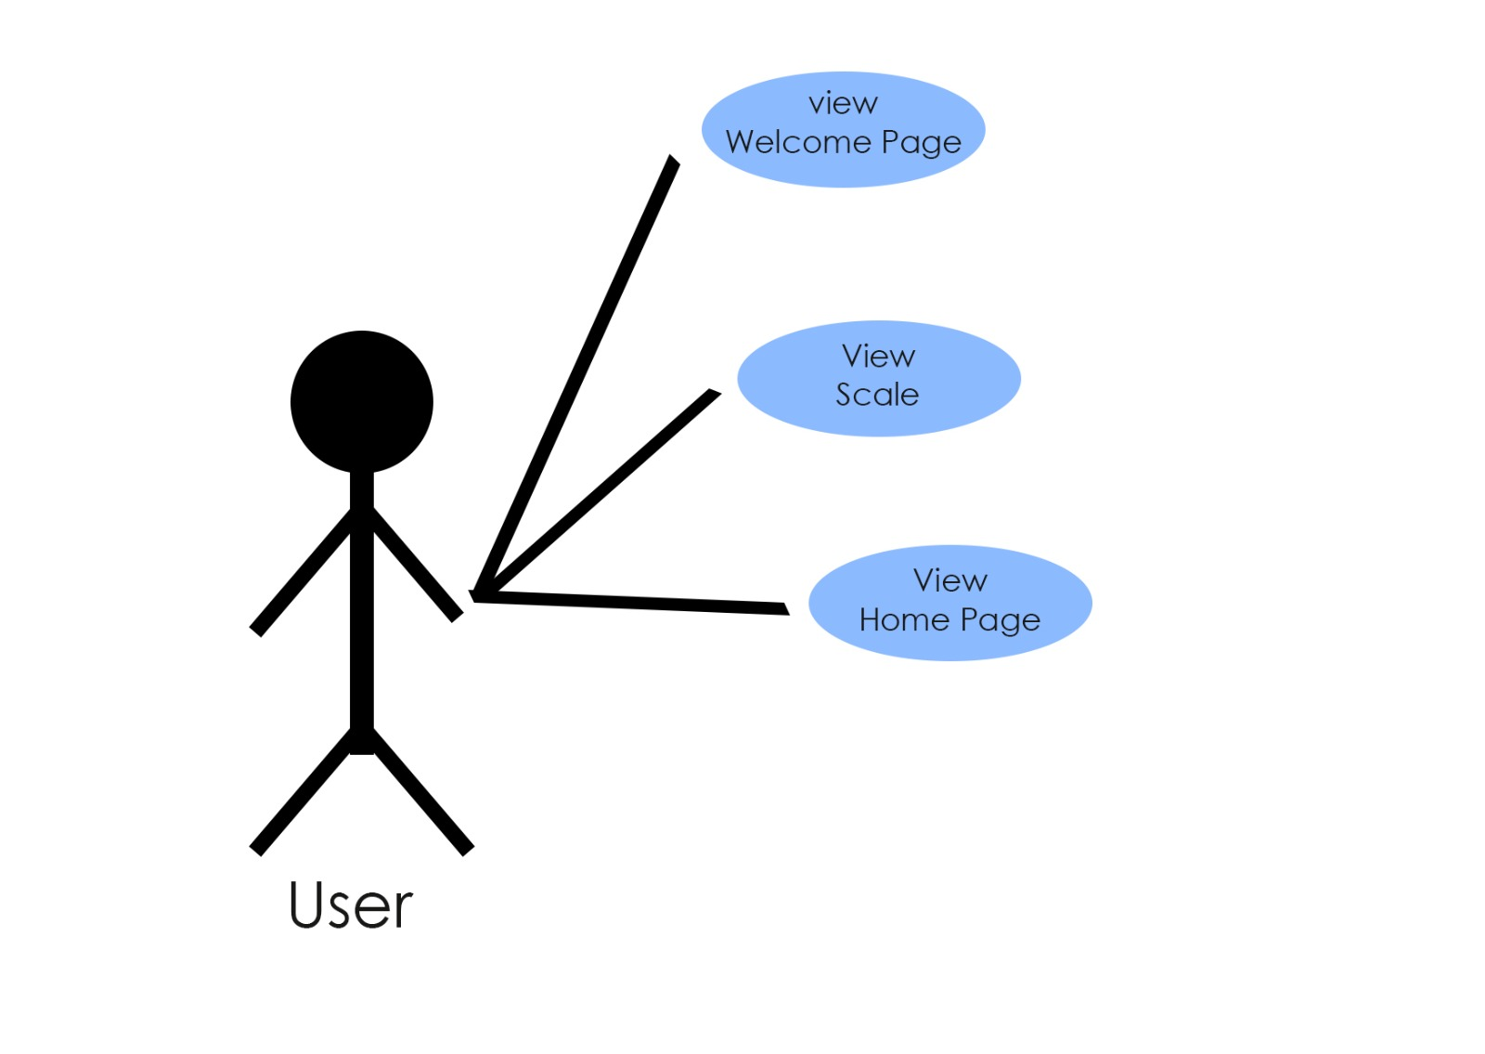

Picture 1 Use Case

In the use case image above, it explains that the user (actor) interacts with a system to achieve a goal to explain the functionality between users and the mobile scale application in the context of weighing spices.

This mobile application has one user actor, namely, housewives. The scenario of this use case is that the user can open the application page, view the application and run the dashboard.

* 1. **ER Diagram.**

ER Diagram is a form of diagram that includes relationships between data objects and relationships. ER Diagram functions as a structure and relationship between data and so on.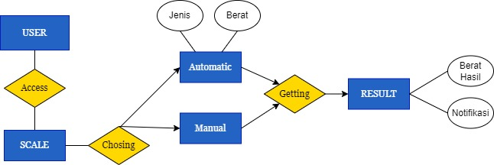

Picture 2 Er Diagram

In the ERD above you can see that the application diagram has 5 entities and each entity has several attributes. When users can manage the welcome page, start page, dashboard and automatic scale page features. Product interface/architecture design.

* 1. **Programming language.**

The programming language we use in this mobile scale application is as follows:

1. **Phyton**

In the context of scaled mobile applications, Python may not be the first choice for live application development. However, Python can still play a role in various aspects of scalable mobile application development. Data processing, Backend Services, Machine Learning and Artificial Intelligence, Automation and Automation, Development of Tools.

1. **C++**

C++ has a significant role in the development of scaled mobile applications, especially in several contexts, one of which is full Control of Devices and Hardware: Large-scale mobile application development may require full control of devices and hardware, such as accessing sensors, cameras, or other specialized hardware.

The following is the code for the Arduino IDE:

#include <WiFi.h>

#include <WebServer.h>

#include "HX711.h"

const char* ssid = "SKSD";

const char* password = "19910011";

const int LOADCELL_DOUT_PIN = 4;  // DOUT pin of HX711 connected to ESP32 GPIO 4

const int LOADCELL_SCK_PIN = 2;   // SCK pin of HX711 connected to ESP32 GPIO 2

HX711 scale;

WebServer server(80);

void handleRoot() {

  server.send(200, "text/plain", "ESP32 Scale with HX711 initialized");

}

void handleData() {

  float weight = scale.get_units(10);  // Get weight in grams

  if (weight < 1) {

    weight = 0;

  }

  String data = String(weight, 1);     // Convert float to String with 1 decimal place

  server.send(200, "text/plain", data); // Respond with weight data

}

void setup() {

  Serial.begin(115200);

  delay(100);

  // Initialize the scale

  scale.begin(LOADCELL_DOUT_PIN, LOADCELL_SCK_PIN);

  scale.set_scale(2280.f);  // Set calibration factor

  scale.tare();             // Reset scale to 0

Serial.println("HX711 initialized");

  // Connect to Wi-Fi

  Serial.print("Connecting to ");

  Serial.println(ssid);

  WiFi.begin(ssid, password);

  while (WiFi.status() != WL_CONNECTED) {

    delay(1000);

    Serial.println("Connecting to WiFi...");

  }

  Serial.println("WiFi connected");

  Serial.print("IP address: ");

  Serial.println(WiFi.localIP());

  // Configure web server routes

  server.on("/", handleRoot);

  server.on("/data", handleData);

  // Start server

  server.begin();

  Serial.println("HTTP server started");

}

void loop() {

  server.handleClient();  // Handle client requests

  // Get the weight in grams

  float weight = scale.get_units(10);

  if (weight < 1) {

    weight = 0;

  }

  // Display the weight on Serial Monitor

  Serial.print("Weight: ");

  Serial.print(weight, 1); // Print weight with 1 decimal place

  Serial.println(" g");

  delay(2000); // Update every 500ms

}

# PRODUCT IMPLEMENTATION

## Product Implementation

Product implementation for mobile application projects:

1. **Implementation for user interface / product design.**

Product implementation for application projects:

* Application Architecture

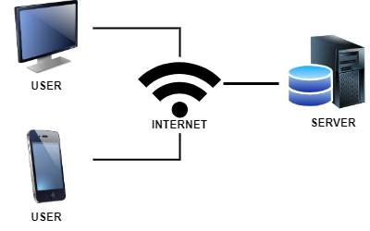

Picture 3 Interface Design

The image above is the application architecture design for a mobile scale application. Where users can access websites using the internet network so they will be connected to this mobile scale (great scale) server.

* Application Scheme

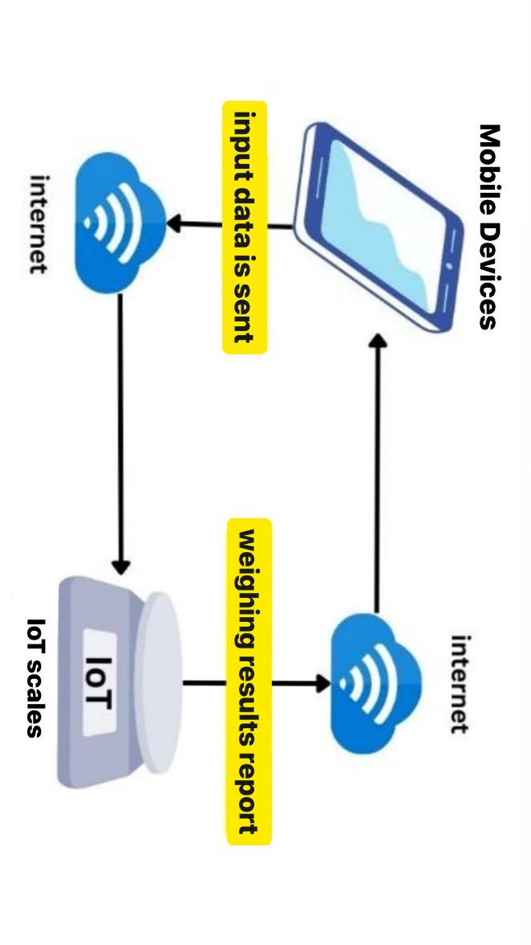

Picture 4 Scheme Design

1. **Product testing result.**
   1. Implemented features

* Logo Implementation



Picture 5 Logo

The logo display for this mobile scale application has a design with a concept on the curve that resembles a scale. And the left and right sides of this logo are inspired by Indonesian batik cloth, namely rangrang batik. The blue and yellow colors were chosen to provide a bright and attractive appearance without being too flashy. The batik pattern inserted provides a touch of local culture that can attract the user's attention. The harmony of colors and patterns helps create a consistent visual identity for the “Scale”.

Previous logo display:

  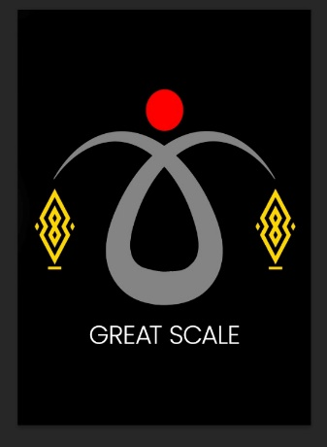 

Picture 6 Previous Logo

* Main Page Implementation

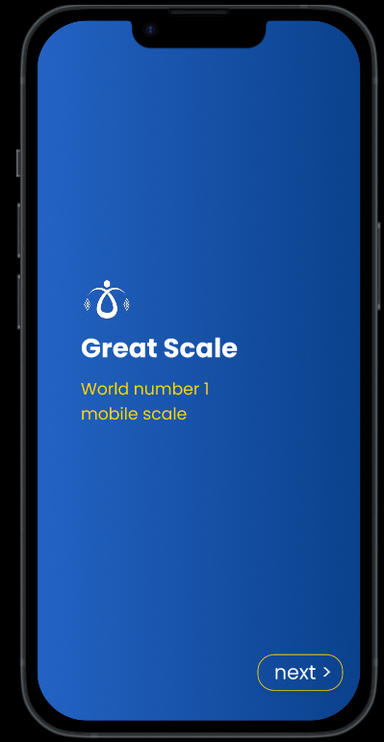 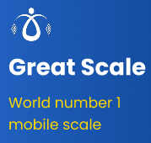 

Picture 7 Welcome Page

This part of the main page makes it easier for users to use the application without having to log in first, just press the next button in the bottom right corner "next".

* Dashboard Page Implementation

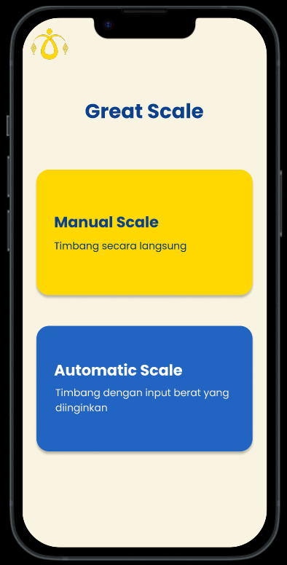

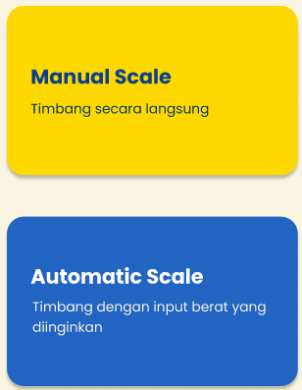

Picture 8 Dashboard

The dashboard design is very simple and simple, so that users are not confused when they want to use this application. We have two features on this page namely ”Manual Scale” and “Automatic Scale”.

* Start page implementation (manual scale)

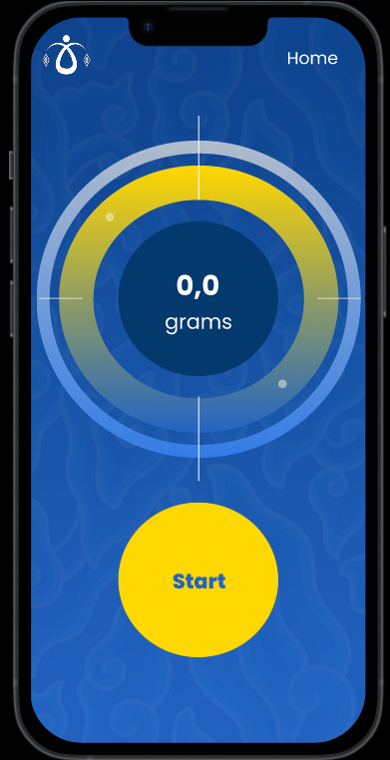 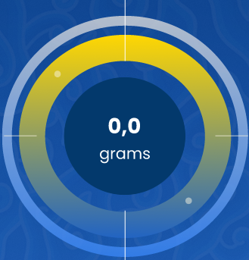

Picture 9 Start Scale

On the manual scale, users can directly weigh any material, with a maximum weighing of 10 kilograms. This page is where users can start the assessment or measurement process directly without inputting anything. The start button is used to start weighing.

* Autoscale Page implementation

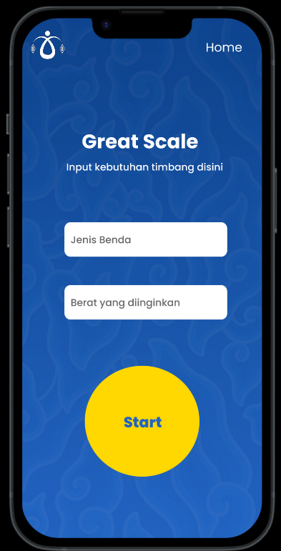 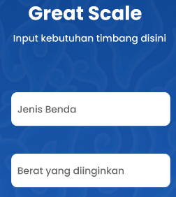

Picture 10 Automatic Scale Page

And in the automatic scale section there is a feature where the user can enter the desired product and weight, the start button starts weighing and there will be a notification if the scale exceeds or is less than the specified weight.

1. **Functional testing of the system by the user**
2. Welcome Page

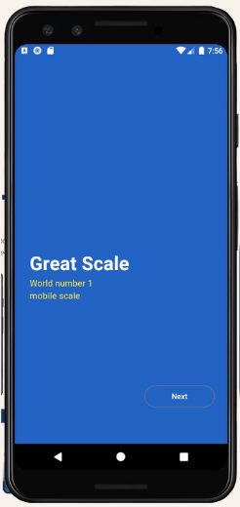

Picture 11 Welcome Page

On the main screen of this application is designed minimally, similar to the interface we created, the only difference being the absence of a logo. There is the application title and a brief explanation as its characteristic. This application does not use a login feature because it facilitates users to use the application without having to register first.

1. Dashboard

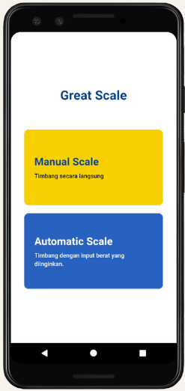

Picture 12 Dashboard

On the second page of this application, there are 2 interesting features for users to use. The first feature is manual scale, which is useful for directly weighing basic ingredients without entering data beforehand. In the second feature, automatic scale functions to weigh according to the user's desire by entering the required numbers.

1. Automatic scale

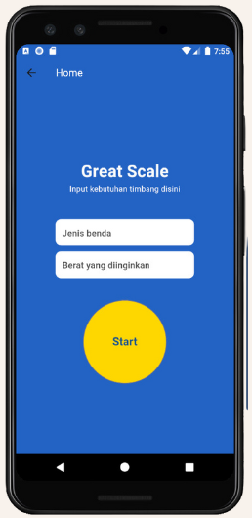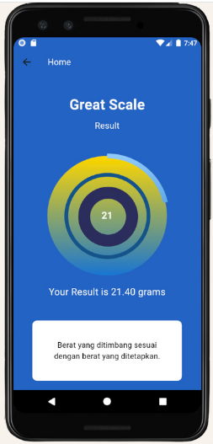

Picture 13 Automatic Scale

On this page displays two buttons that must be filled according to user needs and press the star button if you want to start weighing. After pressing the star button, a circle will appear, which is useful for displaying the weight of the desired need by explaining that the weight being weighed is in accordance with what is filled in the type of object and the desired weight button. This page displays the weight of the object being weighed in a circle already shown on the screen. If you want to weigh other materials, users simply click the reset button.

1. **System Implementation Method**

The system implementation method used to create this application is the Agile Development Approach method, namely an iterative development approach. The development methods we use to achieve our goals include:

1. Planning (planning)

2. Analysis (analysis)

3. Design (design)

4. Implementation (application)

5. Maintenance (application maintenance)

6. Testing and integration (testing and integration)

# CONCLUSION

## 3.1 Obstacle

There were several obstacles that we encountered when working on this PBL project, including:

1. At the start of the we experienced problems with a lack of tools such as breadboards and sensor support equipment.
2. Arduino cannot be connected to the laptop.
3. Create coding for scale applications.

## 3.2 Learning Process

The process for working on this PBL is as follows:

1. In the first week we were still learning the tools and their functions.
2. There are several logo image references that we took from the internet.
3. Solution to the Arduino problem that is not connected, we looked for information on YouTube, from the same PBL team and used reason.

# APPENDIX I – LOGBOOK

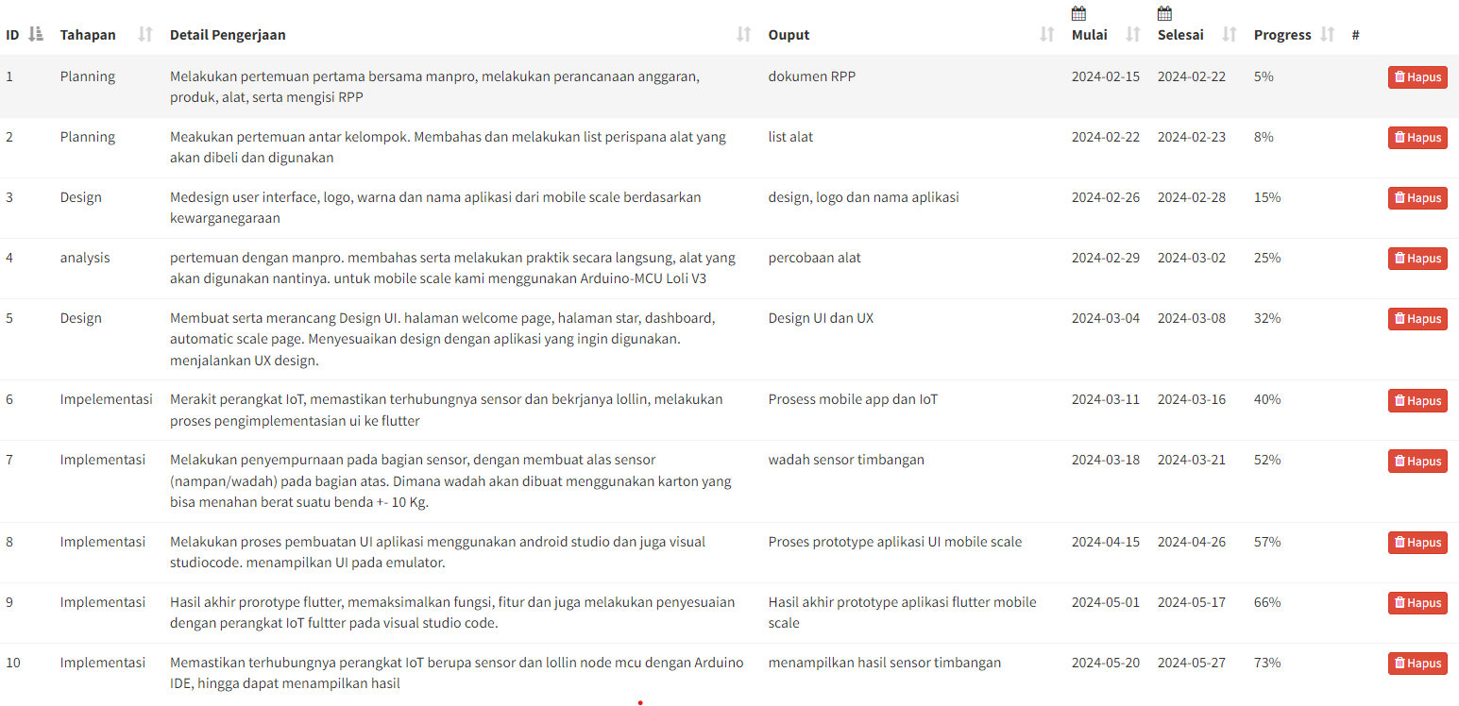

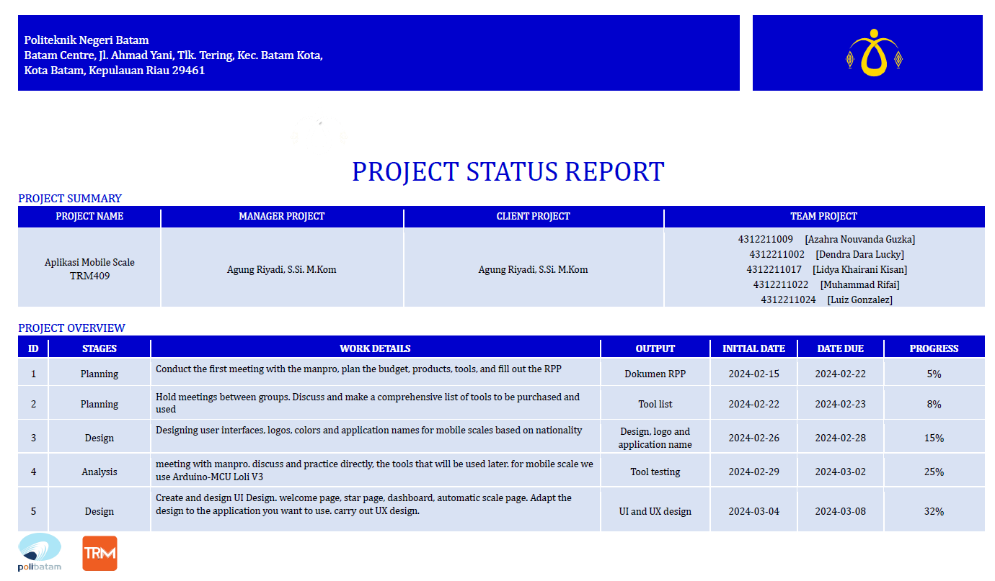

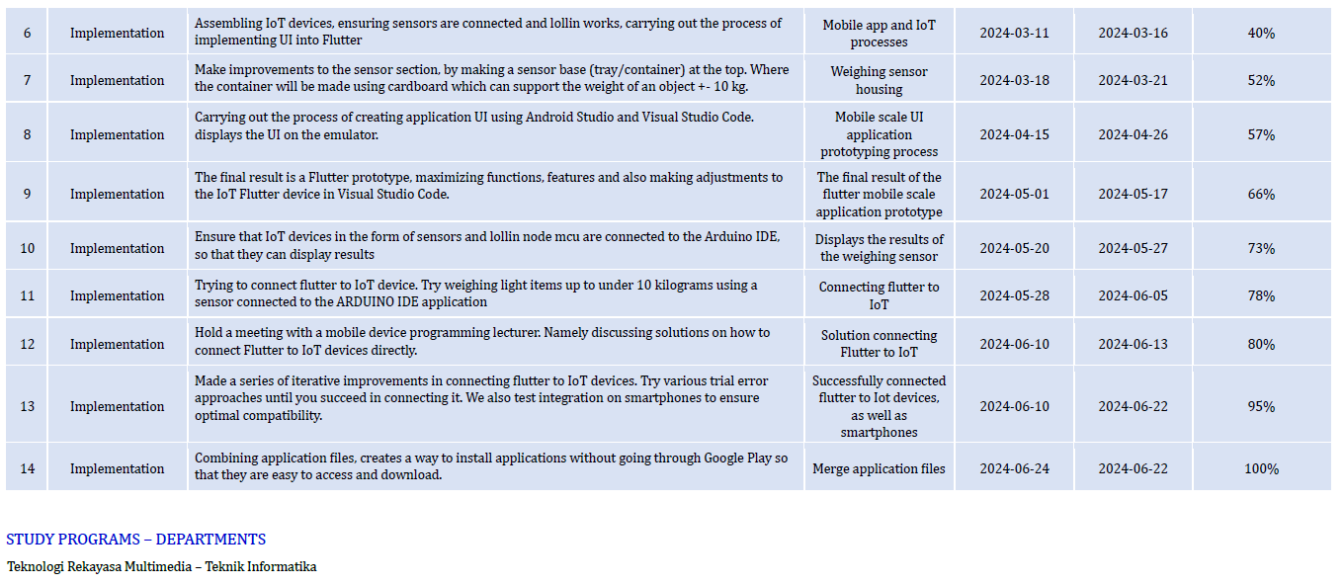

Picture 14 Logbook History

<https://drive.google.com/file/d/1MpD6Acl5Cn_SOQ6Zd85PdElsdBhrtT7j/view?usp=sharing>

# APPENDIX II – TEAM SCHEDULE

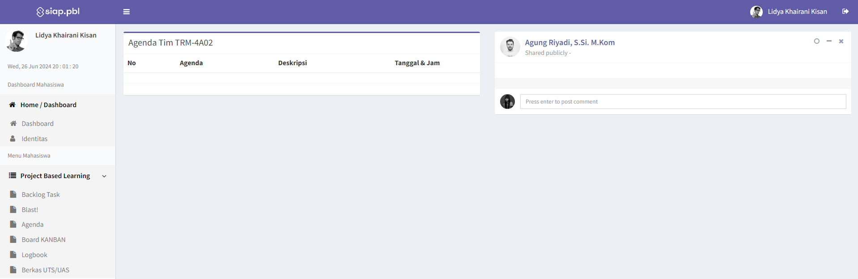

# APPENDIX III – PROJECT BOARD

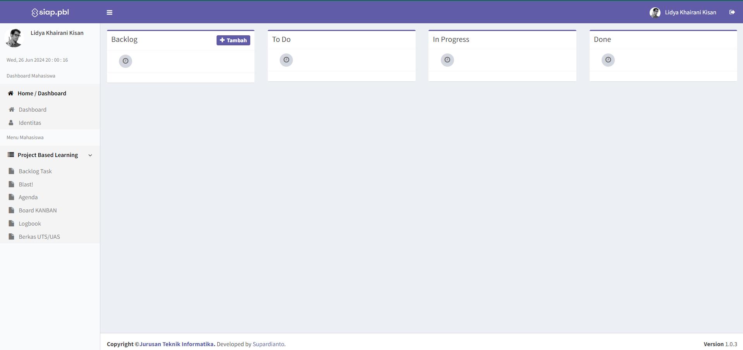

# APPENDIX IV – PRESENTATION SLIDES

<https://drive.google.com/file/d/1flp7RuCH8TDDrNFaHiKuEo6fZKYHbPkR/view?usp=sharing>

Picture 15 ppt presentation

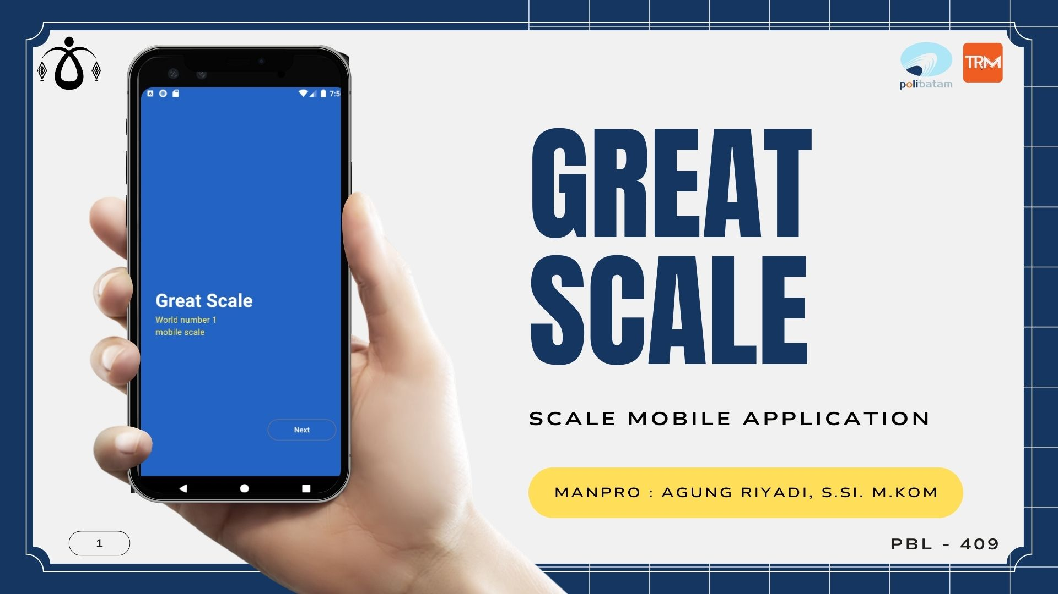

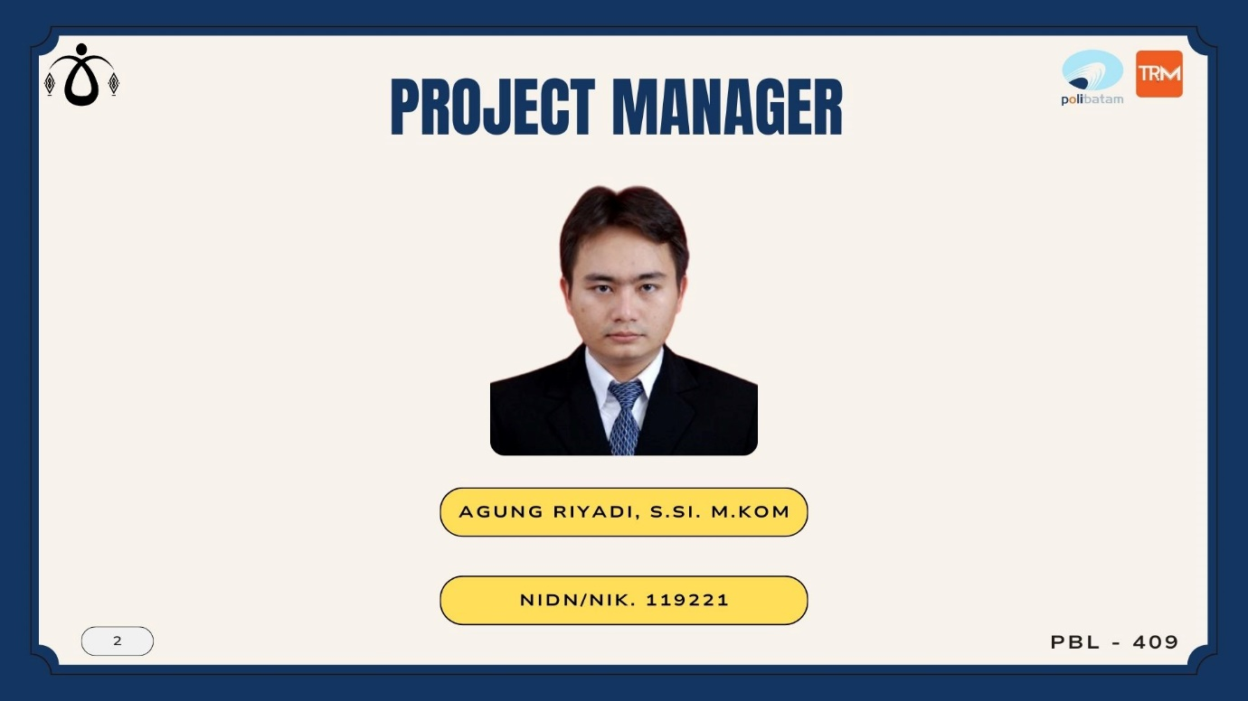

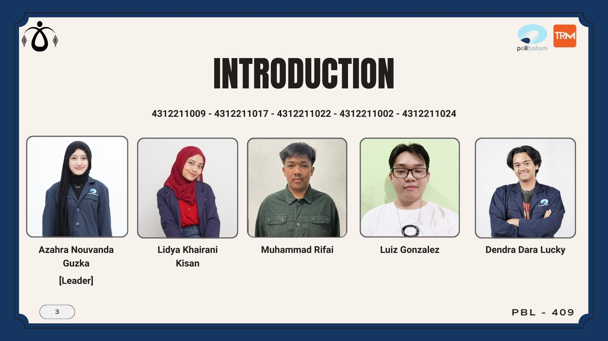

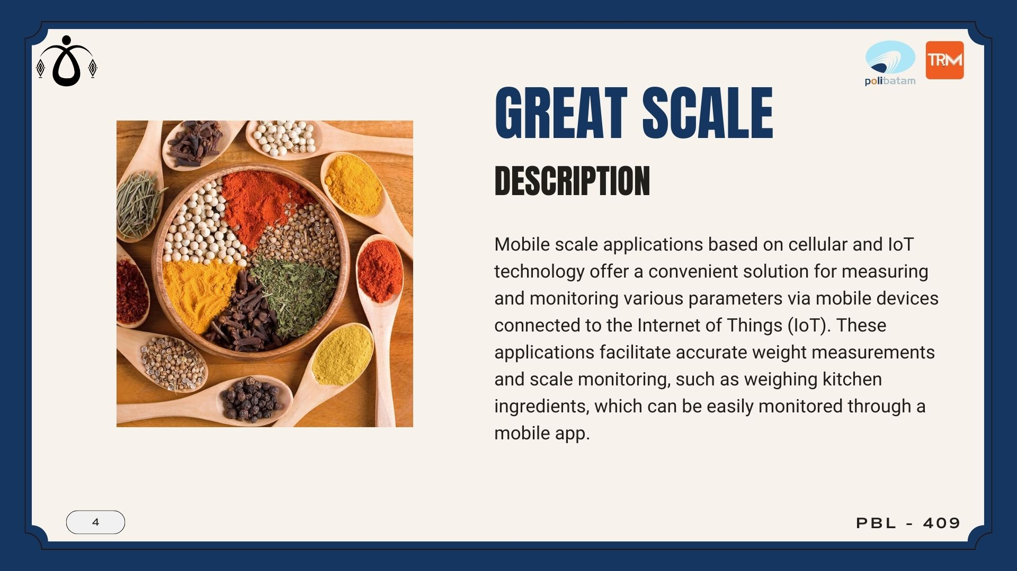

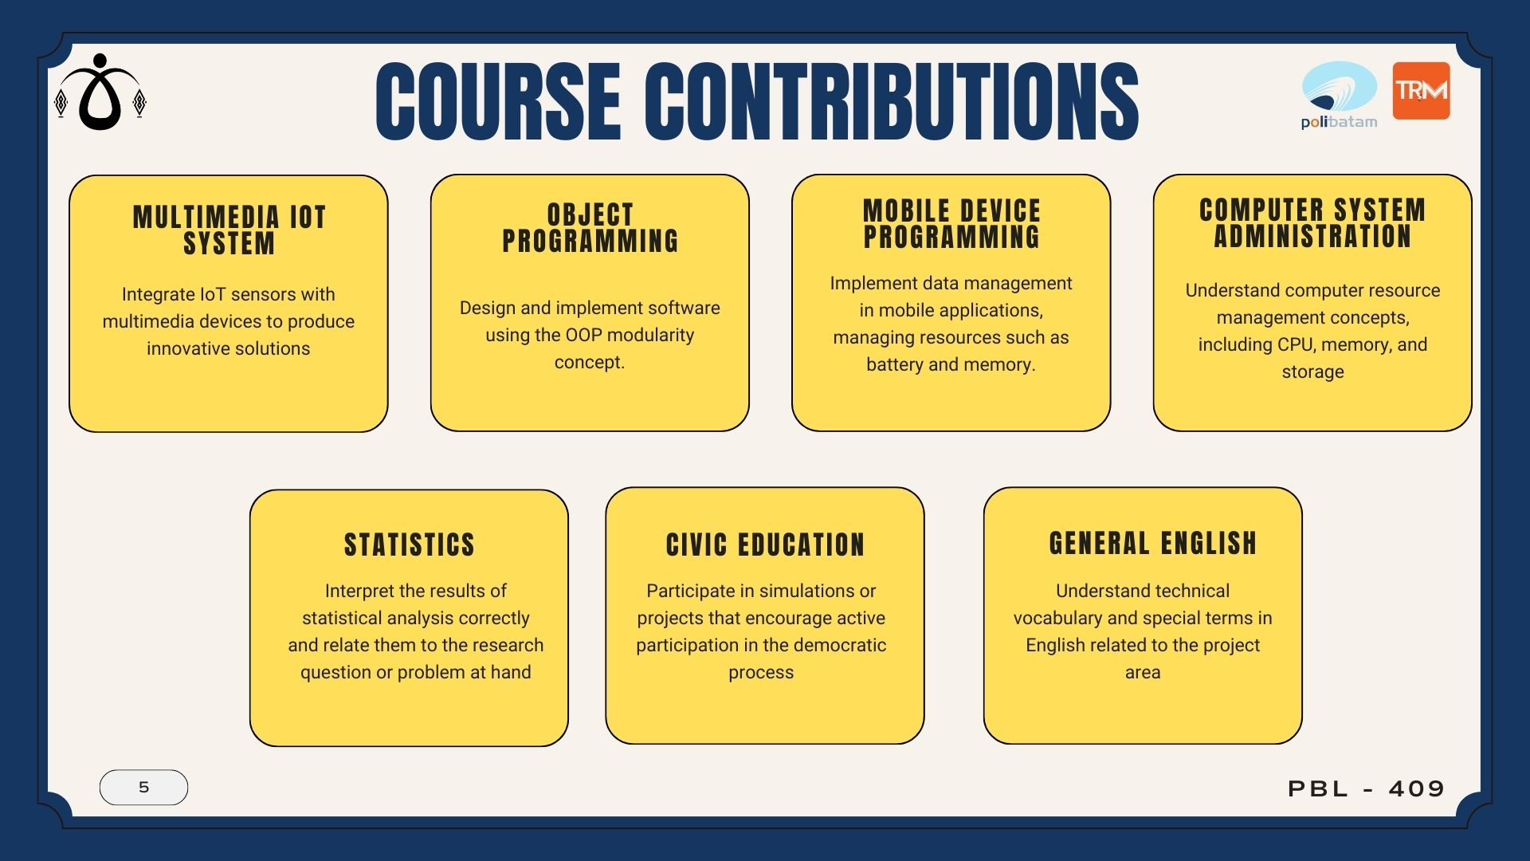

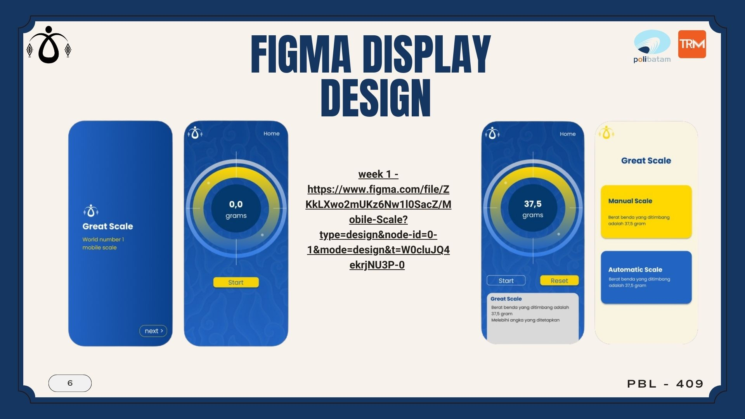

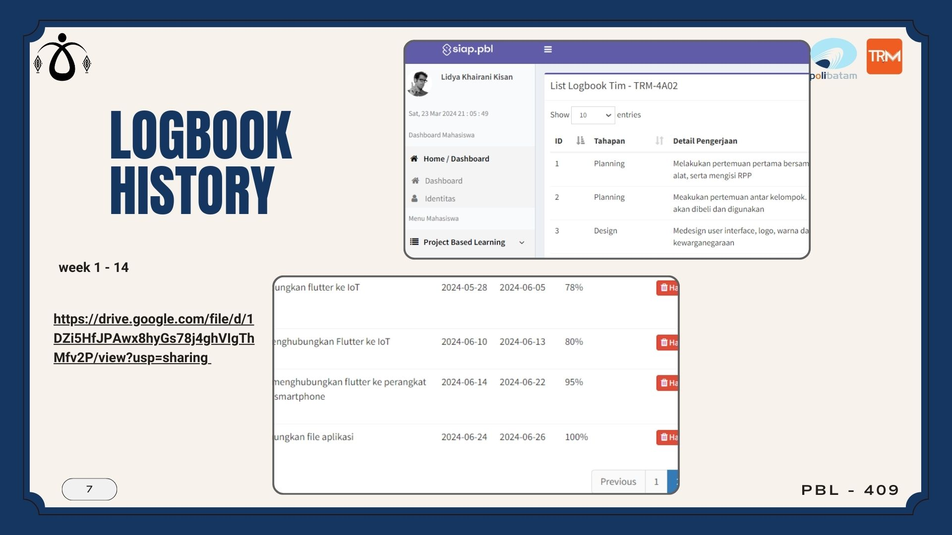

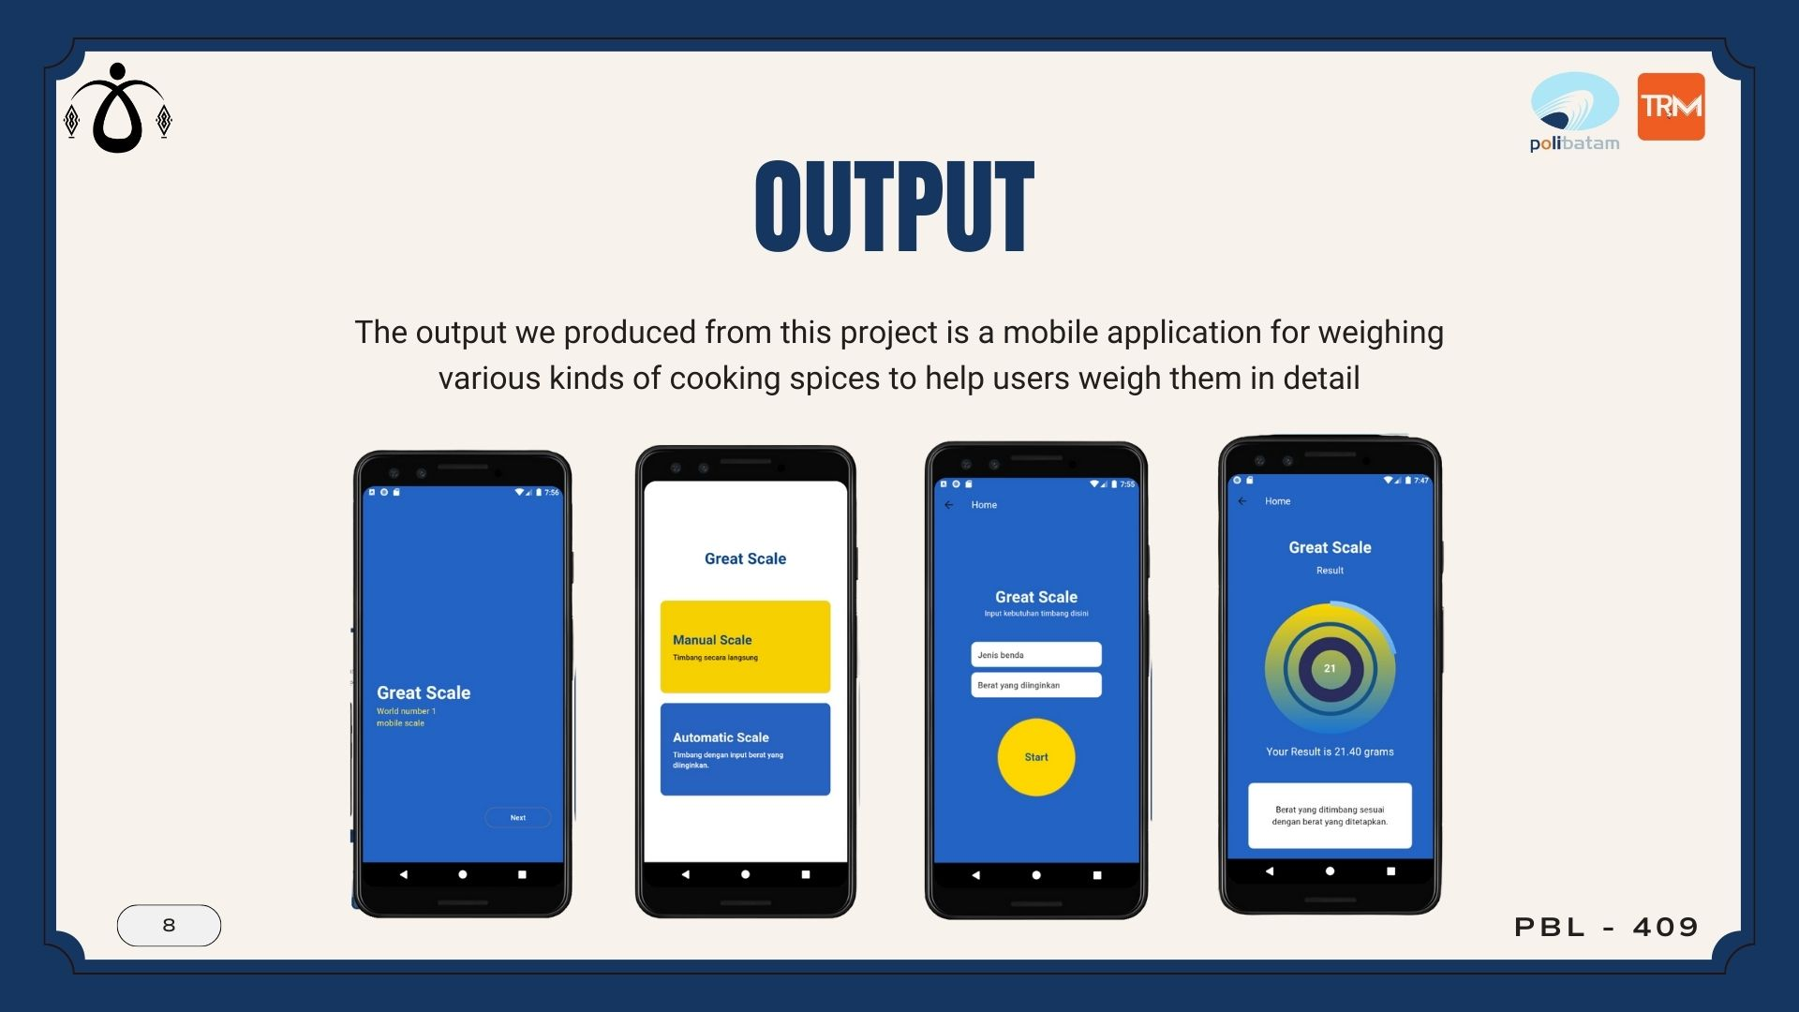

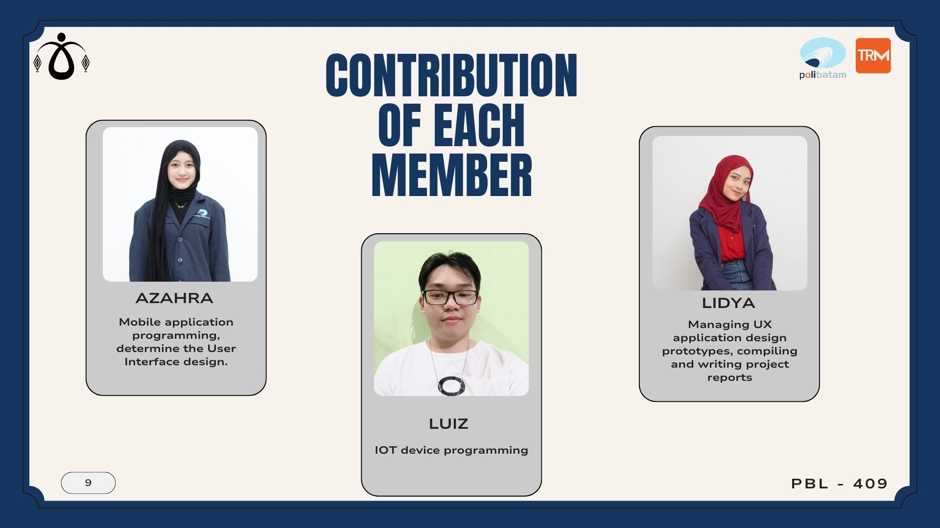

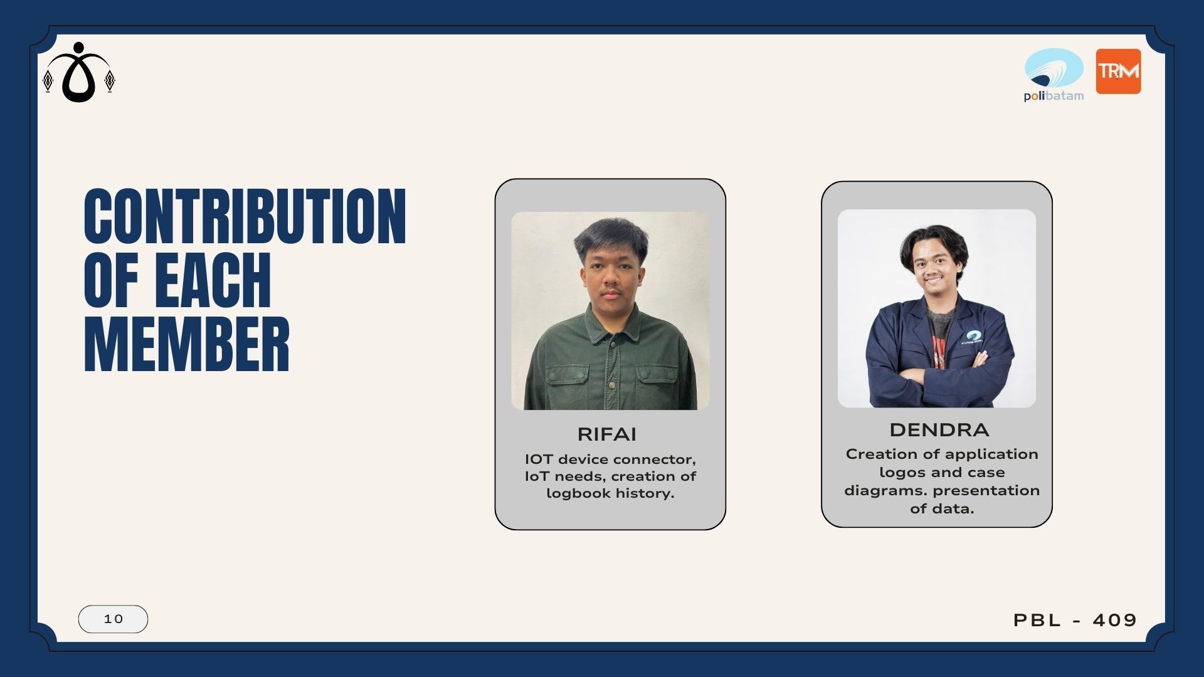

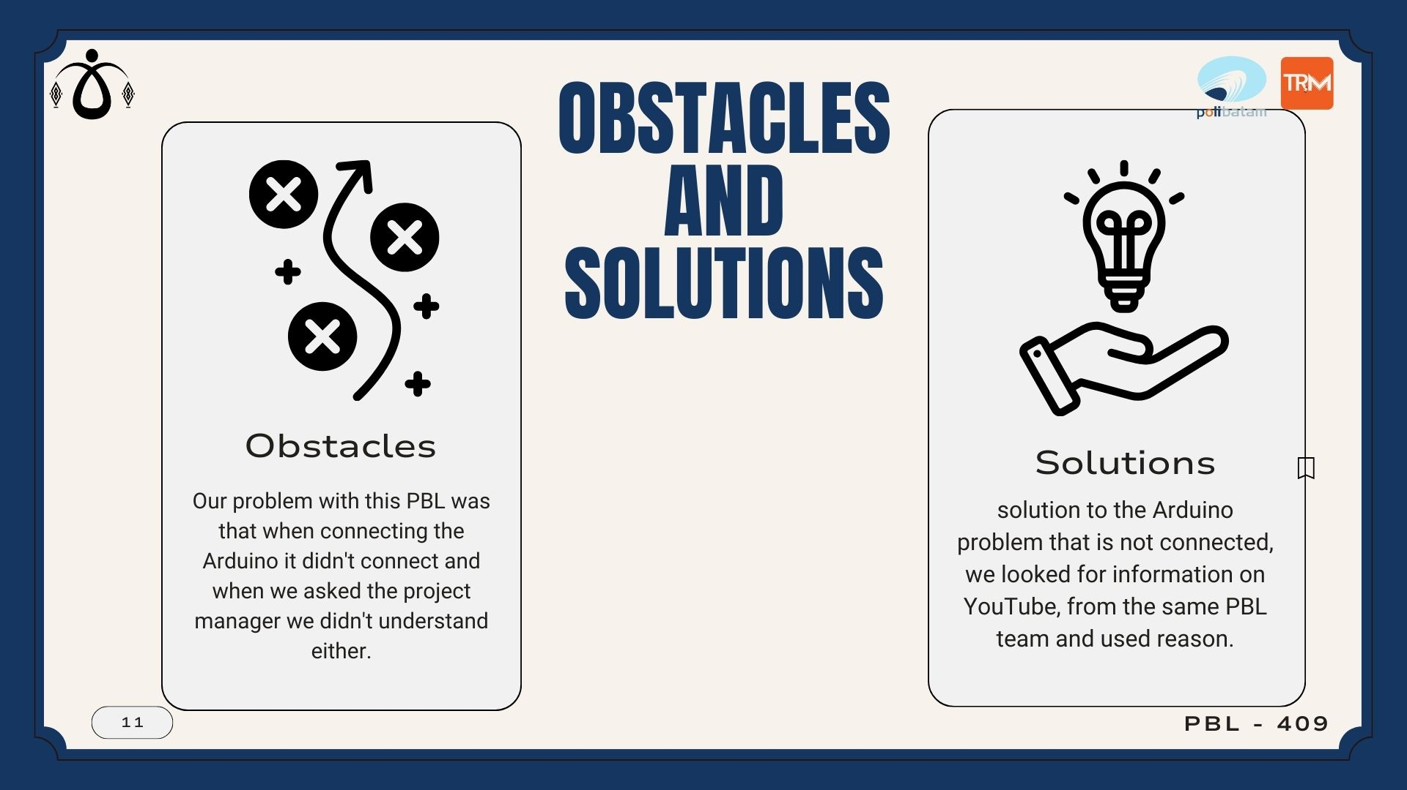

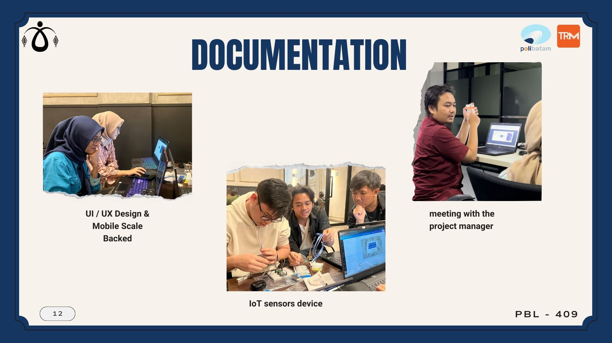

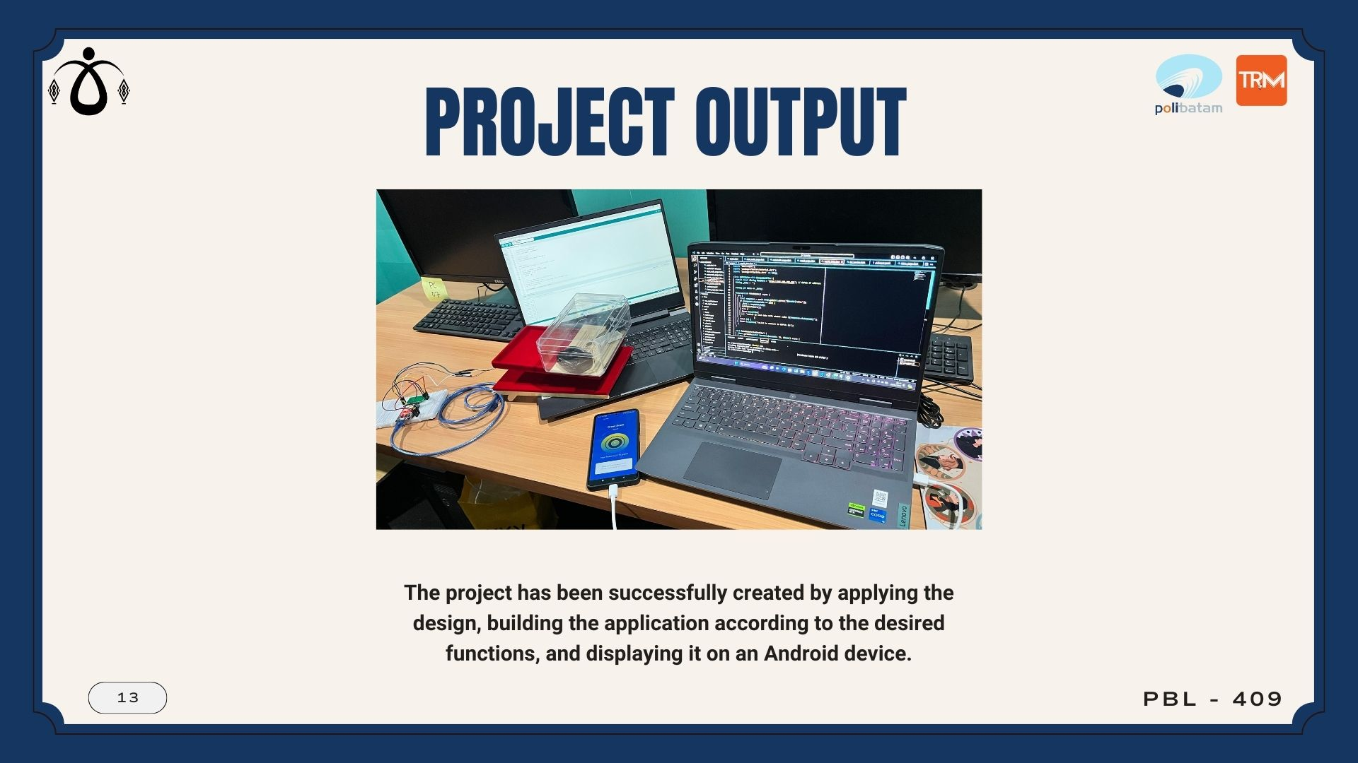

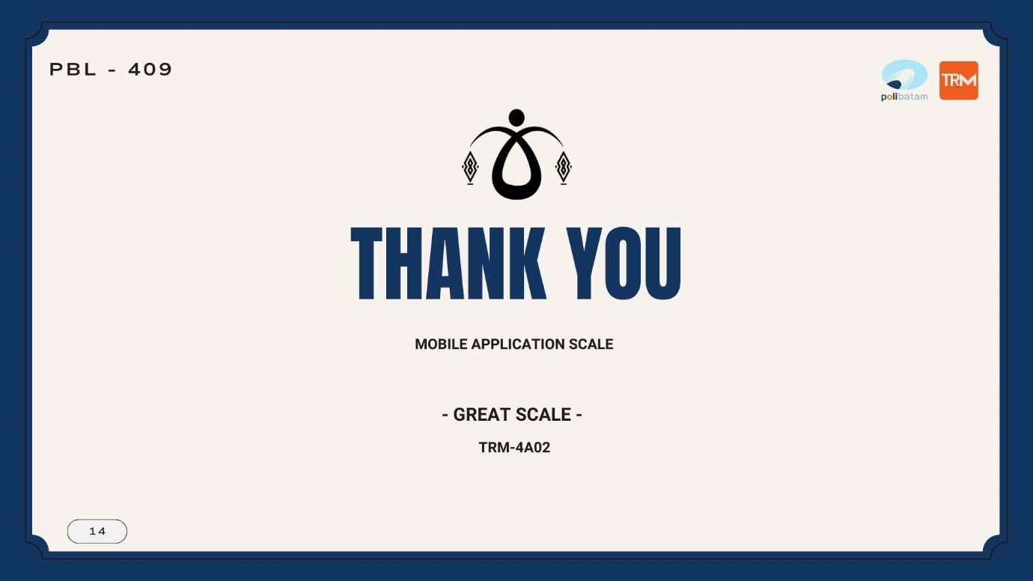

# APPENDIX V

You can add appendices as needed such as:

1. Link of product : [Produsct](https://drive.google.com/drive/folders/1en-0d0J2Tj53YXHHN22KR70OuU3z5ZZB?usp=sharing)
2. Link of presentation : [Presentation](https://drive.google.com/drive/folders/1-fTGbuEI80fiolEMlksTKNZeb4aIRVs1)
3. Link of demo video /teaser : [Demo](https://drive.google.com/drive/folders/19713Ccqo0Pazp5yrRH5e_HPuT8L5Meby?usp=sharing)
4. Link of scientific poster : [Poster](https://www.canva.com/design/DAGJJFqY89k/BCjpYBLf9Kzd_1WFdPjIhA/edit?utm_content=DAGJJFqY89k&utm_campaign=designshare&utm_medium=link2&utm_source=sharebutton)
5. Link of Intellectual Property Rights Document : [Property Rights Document](https://drive.google.com/drive/folders/19713Ccqo0Pazp5yrRH5e_HPuT8L5Meby?usp=sharing)
6. Link of handover document scan : [Handover Document](https://drive.google.com/drive/folders/19713Ccqo0Pazp5yrRH5e_HPuT8L5Meby?usp=sharing)
7. Link Figma : [Figma Design](https://www.figma.com/file/ZKkLXwo2mUKz6Nw1l0SacZ/Mobile-Scale?type=design&node-id=0%3A1&mode=design&t=bPkNbMQOjux59a4N-1)
8. Link of contest proposal (optional) : -
9. Link PPT : [PPT Great Scale [Mobile Scale]](https://drive.google.com/file/d/1flp7RuCH8TDDrNFaHiKuEo6fZKYHbPkR/view?usp=sharing)
10. Link Logbook : [Logbook](https://drive.google.com/file/d/1MpD6Acl5Cn_SOQ6Zd85PdElsdBhrtT7j/view?usp=sharing)
11. Link Manual Book : [Manualbook](https://drive.google.com/file/d/1CH0bMOXhWatsbGhU2apjLLORdlxEg4yN/view?usp=sharing)

Make sure the link provided is set up to be accessible to the **public.**

